**Jenkins Task-1**

**Task Description:**

Launch Jenkins and explore creating projects and users.

Step 1: Setup a Ubuntu EC 2 instance in AWS.



Step 2: For installation on Jenkins it Required Java OpenJDK.

**sudo apt install openjdk-17-jdk -y**

Verify the installation:

**java -version**

**Step 3: Add Jenkins Repository & Install Jenkins**

**-> Add the repository key:**

curl -fsSL https://pkg.jenkins.io/debian/jenkins.io-2023.key | sudo tee \

/usr/share/keyrings/jenkins-keyring.asc > /dev/null

**-> Add the Jenkins repository:**

echo "deb [signed-by=/usr/share/keyrings/jenkins-keyring.asc] \

https://pkg.jenkins.io/debian binary/" | sudo tee \

/etc/apt/sources.list.d/jenkins.list > /dev/null

**-> Update packages and install Jenkins:**

sudo apt update

sudo apt install -y jenkins

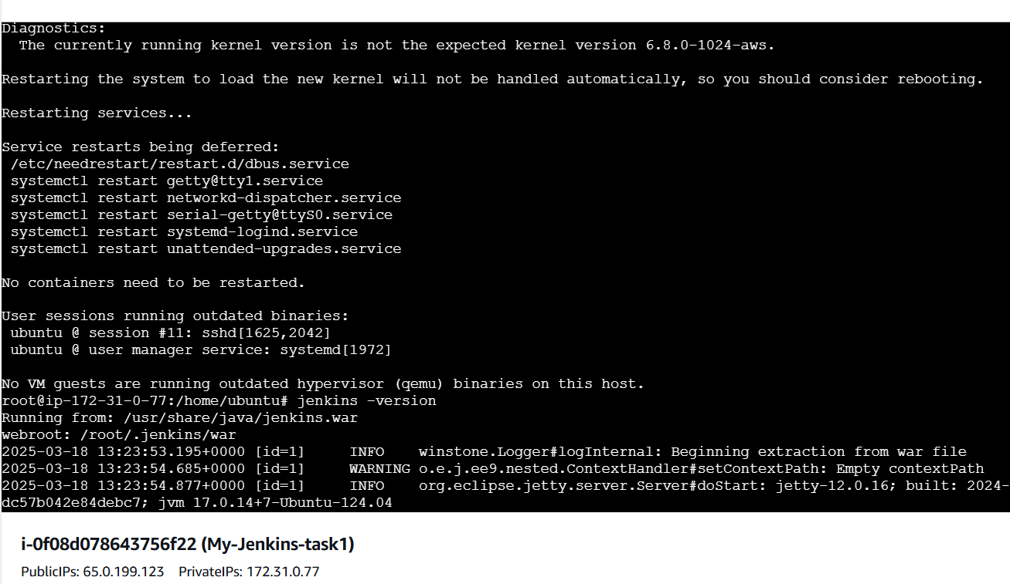

**Step 4: Start and Enable Jenkins**

**sudo systemctl start jenkins**

**sudo systemctl enable Jenkins**

**Check status:**

sudo systemctl status Jenkins

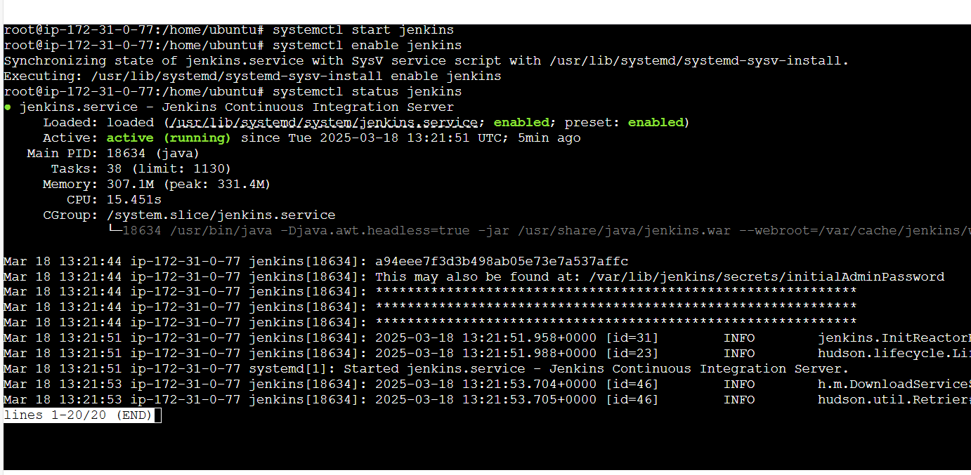

**Step 5: Setup Jenkins**

-> Access Jenkins in a browser

**http://<server-ip>:8080 ( Enable port 8080 In security group)**

-> Retrieve the initial admin password:

**sudo cat /var/lib/jenkins/secrets/initialAdminPassword**

-> Copy and paste the password into the Jenkins setup page.

-> Follow the setup wizard, install recommended plugins, and create an admin user.

Step 6: Creating user.

Step 7: Configure Jenkins Freestyle Job

-> Login to Jenkins (http://<your_jenkins_server>:8080).

-> Click on New Item.

-> Enter a job name (e.g., Python-Freestyle-Job).

-> Select Freestyle project and click OK.

**Step 9: Configure Source Code Management (SCM)**

-> Scroll to the Source Code Management section.

-> Select Git.

-> Enter your repository URL (e.g., https://github.com/user/my_python_project.git).

-> Click Add Credentials if authentication is required.

-> Set the branch to main or another branch you’re using.

**Step 10: Add Build Steps**

-> Scroll down to the Build section.

-> Click Add build step → Execute Shell.

Enter the following script to set up a virtual environment and run tests:

**#!/bin/bash**

**python3 -m venv venv**

**source venv/bin/activate**

**pip install -r requirements.txt**

**python3 -m unittest discover**

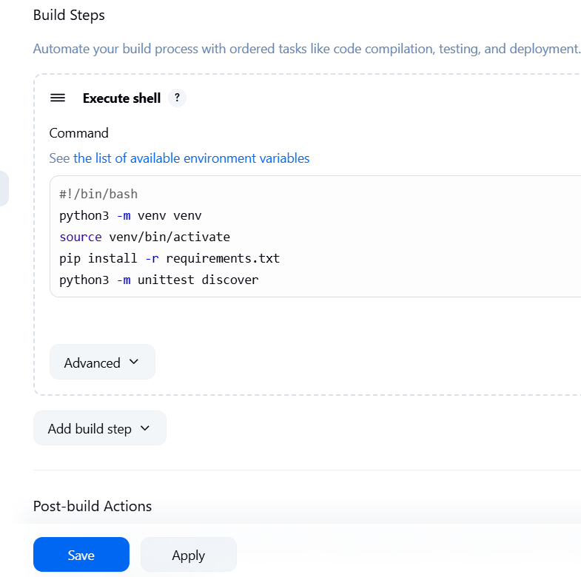

**Step 6: Save and Build**

-> Click Save.

-> Click Build Now to trigger the job.

-> Go to Console Output to verify that:

-> The repository is cloned.

-> The virtual environment is created.

-> Dependencies are installed.

-> Tests are executed.

